**PROCESS OPTIMIZATION IN FRICTION STIR WELDING OF SIMILAR γ- TiAl ALLOYS USING MACHINE LEARNING**

Submitted for the partial fulfillment of the requirement of the Degree of

**Bachelor of Technology**

In

**Metallurgical and Materials Engineering**

**Submitted By**

|  |  |
| --- | --- |
| Panjala Samanvitha | (19120062) |
| Ankam Ravi Varma | (20120015) |
| Challa Kiran Kumar | (20120024) |
| Nimmaka Meghana | (20120062) |
| Vallepu Prabhu Das | (20120103) |



Under the guidance of

**Dr. Naga Sruthi Neelam**

**Assistant Professor**

**DEPARTMENT OF METALLURGICAL AND MATERIALS ENGINEERING**

**NATIONAL INSTITUTE OF TECHNOLOGY RAIPUR**

**2023-2024**



**DEPARTMENT OF METALLURGICAL AND MATERIALS ENGINEERING**

**NATIONAL INSTITUTE OF TECHNOLOGY RAIPUR – 492 010**

# CERTIFICATE

This is to certify that the project entitled “**Process Optimization Of Two Similar ɣ - TiAl Alloys Using ML**” Submitted by Panjala Samanvitha (19120062), Ankam Ravi Varma (20120015), Challa Kiran Kumar (20120024), Nimmaka Meghana (20120062), Vallepu Prabhu Das (20120103) to the department of Metallurgy and Materials Engineering, National Institute of Technology Raipur, for the partial fulfilment of the requirements for the award of the bachelor of technology in Metallurgy and Materials engineering.

**DATE:** 13th December 2023

Dr. Naga Sruthi Neelam Dr. Manoj Kumar Chopkar Asst. Prof & Supervisor Head of the Department

# 



**DEPARTMENT OF METALLURGICAL AND MATERIALS ENGINEERING**

**NATIONAL INSTITUTE OF TECHNOLOGY RAIPUR – 492 010**

**DECLARATION**

This project work is a presentation of our original research work. Wherever contributions of others are involved, every effort is made to indicate this clearly, with due reference to the literature and acknowledgement of collaborative research and discussions. The work has been done under the guidance of Dr. Naga Sruthi Neelam Assistant Professor, Department of

Metallurgical and materials Engineering, National Institute of Technology, Raipur. The result embodied in this report, in full or in parts, has not been submitted, elsewhere for the award of any degree.

Panjala Samanvitha(19120062)

Ankam Ravi Varma(20120015)

Challa KiranKumar(20120024)

Nimmaka Meghana(20120062)

Vallepu Prabhu Das(20120103)

In my capacity as a supervisor of this project work, I certify that the above statements are true to the best of my knowledge.

Dr. Naga Sruthi Neelam

Assistant professor

Department of metallurgical and materials Engg

National Institute of Technology, Raipur

**ACKNOWLEDGEMENT**

We wish to express our gratitude towards of Dr. Naga Sruthi Neelam Mam, Department of

Metallurgical Engineering, for her valuable guidance and time to complete this project successfully. Without her mentorship the project wouldn’t have reached its pinnacle. We also thank her for constantly motivating us during the entire duration of this project.

Last but not the least; we are very much thankful to all the faculty members of Department of Metallurgical and materials engineering, National Institute of Technology, Raipur, who had helped us in some way or the other throughout the project.

Panjala samanvitha (19120062)

Ankam Ravi Varma (20120015)

Challa Kiran Kumar (20120024)

Nimmaka Meghana (20120062)

Vallepu Prabhu Das (20120103)

Department Of Metallurgical and Materials Engineering

National Institute of Technology, Raipur

ABSTRACT 6

KEYWORDS: 6

1. INTRODUCTION 7

**1.1 Gamma Titanium Alloy (γ-Ti-46.5Al-2Cr-5.0 Nb alloy): 7**

**1.2 Friction Stir Welding 8**

1.2.1 Basic Principles Of Friction Stir Welding (Fsw): 9

1.2.2 Process Parameters In Fsw: 10

1.2.3 Advantages Of Fsw: 10

1.2.4 Limitations: 11

**1.3 Machine Learning 11**

1.3.1 Key Components And Concepts In Machine Learning: 11

1.3.2 Uses Of Machine Learning: 11

1.3.3 Machine Learning In Metallurgy: 12

2. OBJECTIVE 13

3. METHODOLOGY 14

**3.1 Data Collection: 14**

**3.2 Implementation of Machine Learning Algorithms: 14**

4. RESULTS AND DISCUSSION 18

**4.1 Decision Tree Algorithm 18**

**4.2 Random Forest Algorithm 19**

**4.3 Gradient Boosting Algorithm 20**

5. CONCLUSION & FUTURE SCOPE OF WORK 21

**Future Scope Of Work: 21**

REFERENCES 22

ABSTRACT

Friction Stir Welding (FSW) has emerged as a promising solid-state welding technique for advanced materials, particularly in the aerospace industry where γ-TiAl alloys are increasingly employed due to their exceptional high-temperature strength-to-weight ratios. This research focuses on the process optimization of FSW for joining two similar γ-TiAl alloys.

Friction Stir Welding (FSW) stands out as a promising technique for joining advanced materials, especially in the context of γ-TiAl alloys, owing to its ability to mitigate thermal distortion and preserve material properties. This research focuses on the process optimization of FSW for welding two similar γ-TiAl alloys, aiming to enhance the tensile strength of the welded joints. The optimization process involves the identification and refinement of key welding parameters, such as tool rotational speed, traverse speed, and axial force.

By leveraging ML algorithms, a predictive model is developed to estimate tensile strength based on the selected welding parameters. This research contributes to the field by showcasing the efficiency of machine learning in predicting tensile strength in FSW of similar γ-TiAl alloys.

KEYWORDS:

γ-TiAl alloy, Friction Stir Welding (FSW), Machine Learning, FSW of Similar γ-TiAl alloys

1. INTRODUCTION

1.1 Gamma Titanium Alloy (γ-Ti-46.5Al-2Cr-5.0 Nb alloy):

γ-TiAl alloys find applications in high-temperature aero-engines and turbochargers for high-performance vehicles. These alloys exhibit excellent resistance to oxidation and creep, along with favourable specific strength; however, their ductility is relatively low. The intermetallic nature of γ-TiAl alloys positions them as promising materials for structural components in high-temperature applications, particularly in turbine blades and wheels for turbochargers in advanced combustion engines [1].

Titanium aluminide (TiAl) belongs to the category of intermetallic materials and is distinguished by its unique mechanical properties derived from its crystal structure. Noteworthy characteristics of TiAl include a high melting point, low density, exceptional thermal stability, elevated specific strengths and moduli, low diffusivity, structural stability, resistance against oxidation and corrosion, and heightened ignition resistance. These properties render TiAl an appealing material for potential substitution of nickel-based superalloys in aerospace applications, particularly in certain components of aircraft engines operating under high-temperature conditions [2].

Despite its high strength, TiAl exhibits drawbacks such as low ductility, reduced fracture toughness, and brittleness at room temperature. This brittleness at ambient conditions imposes limitations on the applications of TiAl alloys. Currently, the engineering service temperature limit for TiAl alloys is approximately 750 °C, primarily attributed to insufficient strength and creep resistance beyond this temperature threshold [2].

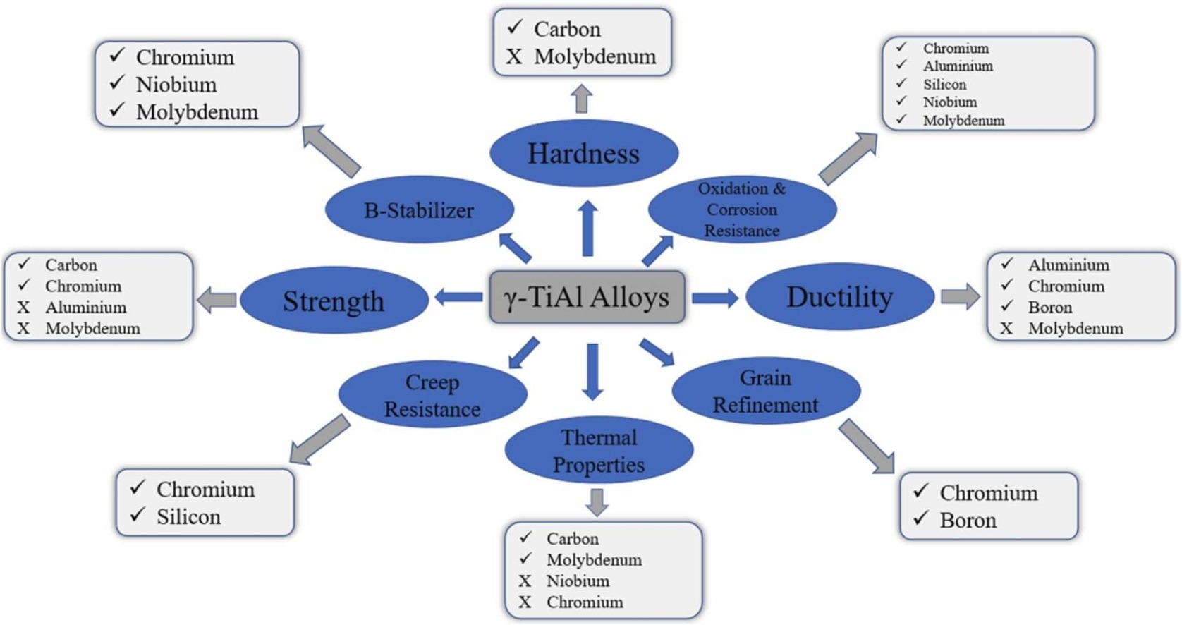

**Fig.1. Properties of** **γ-TiAl alloys**

The utilization of TiAl-based alloys holds promise for enhancing the thrust-to-weight ratio in aircraft engines, particularly evident in components such as the low-pressure turbine blades and high-pressure compressor blades. Traditionally constructed from Ni-based superalloys, these components exhibit nearly double the density of TiAl-based alloys. Certain gamma titanium aluminide alloys demonstrate the ability to maintain strength and oxidation resistance up to 1000 °C, a notable improvement compared to the operational temperature limit of conventional titanium alloys, which stands at 400 °C lower.

* 1. FRICTION STIR WELDING

Friction Stir Welding (FSW) is a groundbreaking solid-state welding process that revolutionizes traditional fusion welding techniques. Introduced in 1991, FSW has gained prominence for its unique attributes and diverse applications in joining materials without the need for melting. Its significance in the field of welding technology lies in addressing key challenges associated with conventional methods [3]. FSW operates at temperatures below the melting point of the materials being joined. Unlike traditional welding processes that involve melting and solidification, FSW minimizes heat input. This characteristic not only preserves the base material's properties but also reduces the risk of thermal distortion and related defects. One of the distinguishing features of FSW is its ability to minimize thermal distortion in the welded materials. By avoiding the introduction of molten metal, the process significantly reduces the heat-affected zone, contributing to improved dimensional stability and the preservation of the material's original structure.

FSW produces welds with enhanced mechanical properties compared to conventional welding methods. The solid-state nature of the process results in refined microstructures and superior joint integrity. The absence of fusion-related defects, such as porosity and solidification cracking, contributes to the exceptional mechanical strength, fatigue resistance, and overall performance of the weld [3], [4]. The unique combination of reduced heat input, minimized thermal distortion, and improved mechanical properties positions FSW as a versatile and valuable welding technique. Its applications span various industries, including aerospace, automotive, and marine engineering, where the demand for high-strength, high-quality welds without compromising the inherent properties of the materials is critical. FSW represents a paradigm shift in welding technology, offering a more efficient and reliable means of joining materials, particularly those challenging to weld using traditional fusion methods.

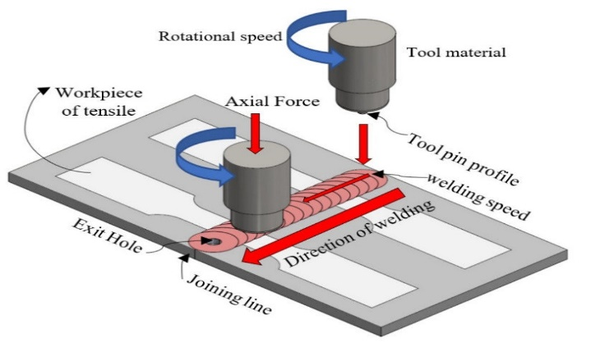

**Fig.2. Schematic Representation of Friction Stir Welding**

1.2.1 Basic Principles of Friction Stir Welding (FSW):

1. **Rotating Tool:** The core element of FSW is the rotating tool. This tool consists of a shoulder and a pin. The shoulder is in constant contact with the surface of the workpieces, and the pin is plunged into the joint between the materials to be welded. The tool is attached to a spindle and rotates at high speeds.
2. **Frictional Heating:** As the rotating tool moves along the joint, the shoulder exerts pressure on the workpieces. This pressure, combined with the rotation of the tool, generates intense frictional forces between the tool and the workpieces. The frictional interaction results in localized heating at the interface between the tool and the materials.
3. **Material Softening:** The generated heat softens the material without reaching its melting point. This state is known as a plasticized or softened zone. The temperature is high enough to induce plastic deformation, allowing the material to become malleable without undergoing a phase change into a liquid.
4. **Mechanical Stirring:** The rotating tool not only generates heat but also mechanically stirs the softened material. The pin, with its unique geometry, actively stirs and agitates the plasticized material around it. This stirring action promotes the mixing of alloying elements, disrupts the original grain structure, and facilitates the formation of a solid-state bond.
5. **Solid-State Material Joining:** FSW achieves material joining through a solid-state process, meaning that the materials are joined without melting. As the tool progresses along the joint, the plasticized material is forced to flow around the pin, effectively creating a continuous, defect-free weld. The lack of fusion-related processes distinguishes FSW from traditional welding methods.

**Table.1. Benefits Of FSW** 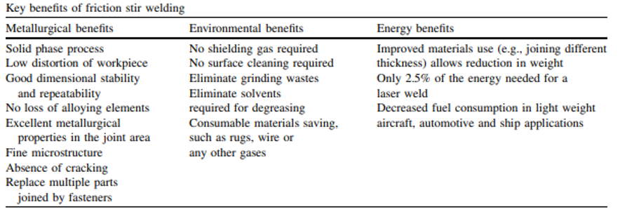

1.2.2 PROCESS PARAMETERS IN FSW:

1. **Rotational Speed:** Rotational speed refers to the speed at which the FSW tool rotates around its axis. It directly impacts the heat generated during the process. Higher rotational speeds generally result in increased heat, affecting the material's plasticization and the overall quality of the weld [5].
2. **Traverse Speed:** Traverse speed is the speed at which the FSW tool moves along the joint. It influences the material flow and, consequently, the welding temperature. Optimal traverse speed ensures proper material mixing and forges a sound weld.
3. **Tool Geometry:** The design of the FSW tool, including shoulder diameter and pin shape, influences material stirring and heat generation. Proper tool geometry is crucial for achieving the desired weld quality [4].
4. **Plunge Depth:** Plunge depth is the depth to which the FSW tool is inserted into the workpiece. It affects the amount of material available for stirring and influences the weld quality [4].
5. **Backing Plate Temperature:** The temperature of the backing plate, if used, can impact the heat dissipation and thermal conditions at the backside of the weld. Controlling the backing plate temperature is crucial for maintaining weld integrity [6].

1.2.3 ADVANTAGES OF FSW:

1. **Reduced Heat Input:** FSW operates at lower temperatures compared to traditional welding processes, minimizing the heat-affected zone and preserving the material properties [4].
2. **Minimized Thermal Distortion:** The solid-state nature of FSW reduces thermal distortion in the welded materials, resulting in improved dimensional stability [5].
3. **Improved Mechanical Properties:** FSW produces welds with enhanced mechanical properties, including high tensile strength, fatigue resistance, and improved toughness.
4. **Versatility in Material Compatibility:** FSW is applicable to a wide range of materials, including aluminum, magnesium, copper, and various alloys, expanding its usability across industries [4].

1.2.4 LIMITATIONS:

1. **Equipment Cost:** The initial setup cost for FSW equipment, including the specialized rotating tool and control systems, can be relatively high [4].
2. **Surface Finish:** The FSW process can leave a noticeable surface texture on the welded joint, which may require additional processing or finishing steps [4].

1.3 MACHINE LEARNING

Machine Learning (ML) is a subfield of artificial intelligence (AI) that focuses on the development of algorithms and statistical models that enable computer systems to perform tasks without explicit programming. The fundamental concept behind machine learning is the ability of a system to learn from data, recognize patterns, and make decisions or predictions based on that learning [7].

1.3.1 KEY COMPONENTS AND CONCEPTS IN MACHINE LEARNING:

1. **Data:** Machine learning relies heavily on data. Large volumes of relevant and representative data are used to train models. This data is typically divided into training and testing sets.
2. **Algorithms:** ML algorithms are mathematical models that process input data to produce an output or prediction. Common algorithms include decision trees, support vector machines, neural networks, and clustering algorithms.
3. **Training Process:** During the training phase, the algorithm iteratively adjusts its parameters to minimize the difference between its predictions and the actual outcomes in the training data.
4. **Testing and Evaluation:** After training, the model is tested on new, unseen data to assess its generalization performance. Evaluation metrics help measure the model's accuracy, precision, recall, or other relevant criteria.
5. **Supervised and Unsupervised Learning:** In supervised learning, the model is trained on labeled data, where the correct output is provided. In unsupervised learning, the algorithm identifies patterns and relationships without labeled data.

1.3.2 USES OF MACHINE LEARNING:

Machine Learning (ML) has become a transformative force across diverse industries, revolutionizing how tasks are approached and insights are derived from data. In healthcare, ML is pivotal for disease prediction, facilitating personalized treatment plans, and advancing the field of medical image analysis [8]. The finance sector harnesses ML algorithms for various applications, including credit scoring, fraud detection, algorithmic trading, and risk management. In the realm of retail and e-commerce, ML powers recommendation systems, optimizes pricing strategies, forecasts demand, and detects fraud in online transactions [9]. The manufacturing sector benefits from ML through improved predictive maintenance, enhanced quality control, optimized supply chain management, and increased process automation. Furthermore, ML's application in Natural Language Processing (NLP) has revolutionized language-related tasks, enabling advancements in translation, sentiment analysis, chatbots, and voice recognition. Across these domains, the integration of ML continues to shape industries, offering innovative solutions and driving efficiency in diverse applications.

1.3.3 MACHINE LEARNING IN METALLURGY:

Machine Learning (ML) plays a pivotal role in various facets of metallurgy, facilitating advancements in material design, process optimization, quality control, and predictive maintenance. ML models prove instrumental in predicting material properties [10], expediting the discovery of novel alloys with desired characteristics. In the realm of process optimization, ML algorithms scrutinize extensive datasets, discern patterns, and recommend parameter adjustments, thereby enhancing the efficiency of metallurgical processes.

Quality control and defect detection benefit from ML models that meticulously identify imperfections in materials, ensuring the production of high-quality metallurgical products. Additionally, ML finds application in predictive maintenance within metallurgical plants, mitigating downtime by proactively anticipating equipment failures. This integration of ML across these domains underscores its transformative impact on the entire metallurgical workflow, from material conception to manufacturing efficiency and product quality [11].

1. OBJECTIVE

γ-TiAl, an alternative to Ni based super alloys for aerospace applications due to its high strength to weight ratio are considered as high temperature structural alloy for various industrial applications. Joining of these alloys would increase their application window but has been a technological hurdle due to their intrinsic brittleness and poor damage tolerance. In the current proposal, friction stir welding of a γ-TiAl alloy containing Nb and Mo with a three phase γ, α2 and β/B2 microstructure with superior creep and isothermal oxidation properties at 800°C and 900°C respectively, with same and similar  TiAl alloy will be carried out. The process parameter optimization for a sound joint is carried out with the help of machine learning.

**Optimization of FSW parameters to obtain a defect free joint of γ-Ti-46.5Al-5Nb-2Mo-0.3B alloy using Machine learning**

* To generate sufficient data set for Machine learning process
* Optimization of process parameters using various ML algorithms – to reduce the experimental trails in obtaining a defect free joint

1. METHODOLOGY

3.1 Data Collection:

Friction Stir Welding (FSW) is mainly used on special types of metals called gamma TiAl alloys, collecting information is very important. Scientists write papers all about it, where they collect a bunch of details like how fast the welding tool spins, how quickly the welding happens, how much pressure is applied, what shape the tool has, and the temperature used during the process. They look closely at all these things to figure out how they affect the metal's structure, strength, and overall performance when using FSW on gamma TiAl alloys [19].

By studying a bunch of data from these papers, scientists can see patterns and connections that help them make FSW work even better for welding similar metals. This helps improve the quality of the welds and how strong they are. In the end, it's like fine-tuning the settings for FSW to make really strong and durable parts out of gamma TiAl alloys.

**Table.2. Range of FSW Process Parameters for γ-TiAl alloys**

|  |  |
| --- | --- |
| ***PROCESS PARAMETER*** | ***RANGE*** |
| *Rotational Speed* | *2000-2500 rpm* |
| *Friction Time* | *30-50 sec* |
| *Upset Pressure* | *300-460 MPa* |
| *Friction Pressure* | *130-170 MPa* |
| *Tilt Angle* | *1-3 deg* |

3.2 Implementation of Machine Learning Algorithms:

The machine learning algorithms' execution procedure is displayed in Fig. 3. The working environment is first filled with the import of all required Python libraries, including pandas, NumPy, seaborn, matplotlib, and seaborn. Following its import into the Google Colab environment, the dataset underwent a second check for missing values. Finally, using a graphical statistical approach, as seen in Fig. 4, exploratory data analysis is performed to assess the dataset and extract the primary characteristics features.

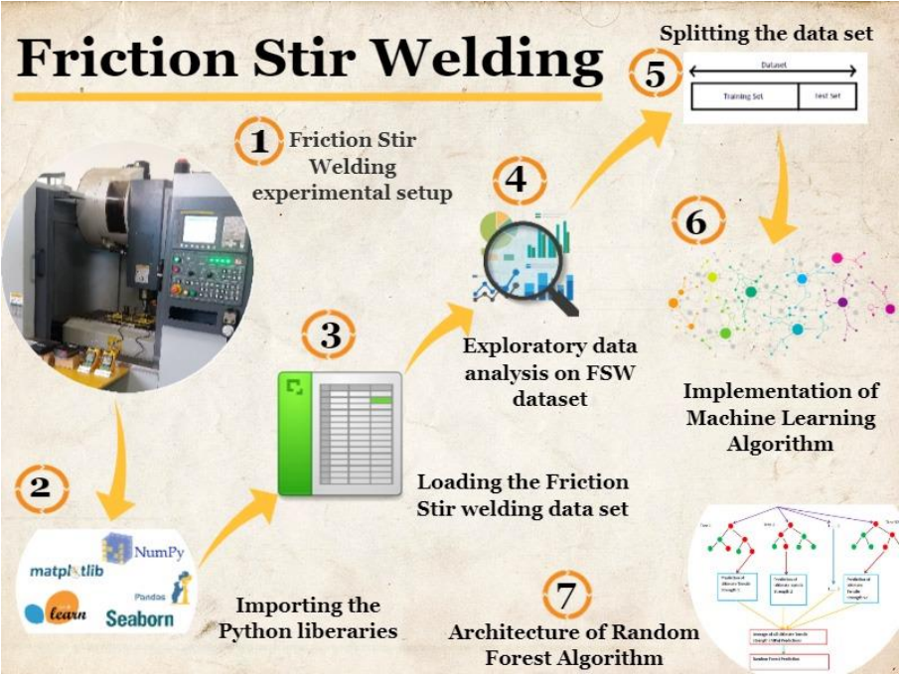

**Fig.3. Pictorial Representation of the execution of Machine Learning algorithms**

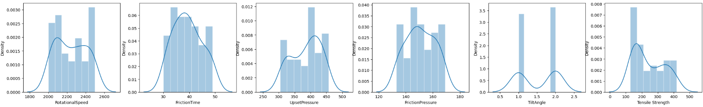

**Fig.4. EDA Analysis on the given dataset**

Fourth, as illustrated in Fig. 5, feature importance for each input feature is determined. The Rotational Speed (RPM) has the greatest influence on the Tensile Strength (MPa), followed by Friction Time (min), Friction Pressure (MPa), and Upset Pressure (MPa). It is also discovered that the Tilt Angle has little effect on the Tensile Strength (MPa).

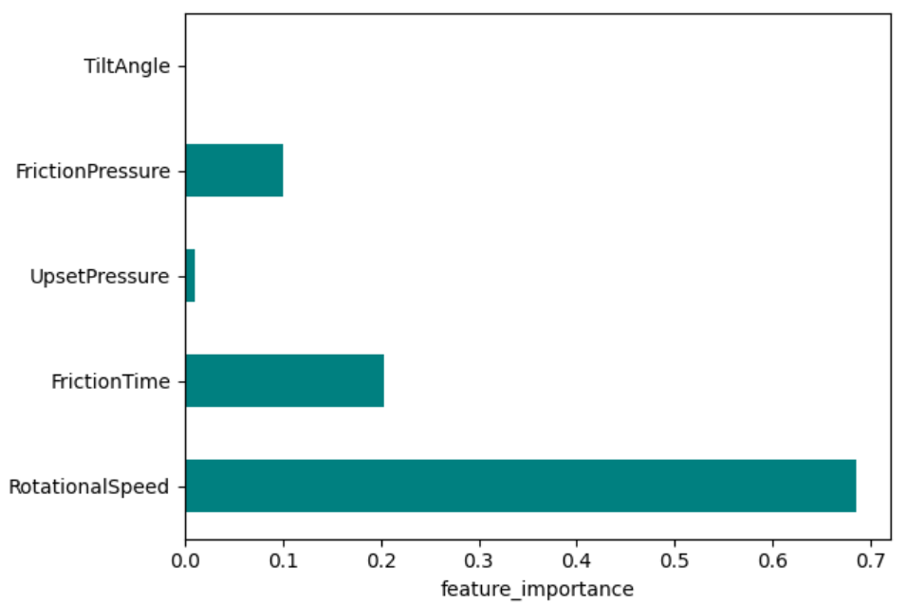

**Fig.5. Plot showing the importance of features**

In the fifth stage, the dataset is split in an 80-20 ratio, which means that 80 percent of the data is utilized for training and 20 percent is used for testing. The value of metrics features such as Mean Square Error, Mean Absolute Error, and coefficient of determination (R2) are calculated in the last stage to assess the effectiveness of the individual Supervised Machine Learning algorithms.

**Table.3. Process parameters and their values**

|  |  |  |  |  |  |  |
| --- | --- | --- | --- | --- | --- | --- |
| **Sl. No** | **Rotational Speed**  **(RPM)** | **Friction Time**  **(sec)** | **Upset Pressure**  **(MPa)** | **Friction Pressure**  **(MPa)** | **Tilt Angle**  **(o)** | **Tensile Strength**  **(MPa)** |
| **0** | 2309 | 35 | 412 | 159 | 1 | 418 |
| **1** | 2041 | 39 | 361 | 145 | 2 | 165 |
| **2** | 2329 | 47 | 442 | 155 | 2 | 410 |
| **3** | 2469 | 38 | 451 | 144 | 2 | 129 |
| **4** | 2232 | 40 | 457 | 160 | 1 | 413 |
| **5** | 2385 | 32 | 352 | 146 | 2 | 390 |
| **6** | 2001 | 34 | 368 | 138 | 2 | 144 |
| **7** | 2363 | 36 | 408 | 165 | 2 | 280 |
| **8** | 2122 | 39 | 448 | 148 | 2 | 166 |
| **9** | 2489 | 32 | 321 | 169 | 1 | 135 |
| **10** | 2200 | 49 | 392 | 146 | 2 | 158 |
| **11** | 2133 | 33 | 403 | 134 | 1 | 149 |
| **12** | 2295 | 35 | 304 | 133 | 1 | 234 |
| **13** | 2055 | 48 | 376 | 150 | 2 | 210 |
| **14** | 2481 | 33 | 381 | 148 | 2 | 359 |
| **15** | 2137 | 49 | 440 | 166 | 1 | 187 |
| **16** | 2077 | 34 | 441 | 165 | 1 | 278 |
| **17** | 2117 | 39 | 420 | 144 | 2 | 143 |
| **18** | 2000 | 42 | 411 | 139 | 2 | 157 |
| **19** | 2395 | 45 | 441 | 144 | 2 | 320 |
| **20** | 2435 | 35 | 368 | 158 | 1 | 336 |
| **21** | 2498 | 38 | 336 | 134 | 1 | 133 |
| **22** | 2317 | 39 | 375 | 158 | 2 | 396 |
| **23** | 2346 | 43 | 405 | 166 | 2 | 348 |
| **24** | 2429 | 40 | 422 | 152 | 1 | 368 |
| **25** | 2268 | 35 | 335 | 159 | 2 | 370 |
| **26** | 2074 | 42 | 307 | 160 | 1 | 179 |
| **27** | 2161 | 46 | 322 | 169 | 2 | 278 |
| **28** | 2099 | 30 | 403 | 143 | 1 | 157 |
| **29** | 2254 | 31 | 359 | 163 | 2 | 269 |
| **30** | 2012 | 37 | 412 | 153 | 1 | 217 |
| **31** | 2063 | 37 | 432 | 152 | 1 | 171 |
| **32** | 2194 | 34 | 442 | 148 | 1 | 163 |
| **33** | 2255 | 46 | 410 | 150 | 1 | 380 |
| **34** | 2291 | 42 | 324 | 135 | 2 | 240 |
| **35** | 2078 | 39 | 314 | 149 | 1 | 217 |
| **36** | 2471 | 44 | 327 | 156 | 1 | 321 |
| **37** | 2060 | 40 | 392 | 133 | 1 | 141 |
| **38** | 2348 | 42 | 416 | 166 | 2 | 333 |
| **39** | 2211 | 47 | 321 | 165 | 1 | 329 |
| **40** | 2052 | 49 | 406 | 137 | 1 | 139 |
| **41** | 2480 | 31 | 319 | 137 | 1 | 127 |
| **42** | 2085 | 44 | 375 | 139 | 2 | 169 |
| **43** | 2111 | 37 | 398 | 149 | 2 | 190 |
| **44** | 2442 | 31 | 422 | 162 | 2 | 160 |
| **45** | 2012 | 37 | 432 | 154 | 1 | 185 |
| **46** | 2370 | 49 | 438 | 140 | 1 | 280 |
| **47** | 2482 | 42 | 342 | 144 | 2 | 173 |
| **48** | 2448 | 38 | 395 | 159 | 2 | 345 |
| **49** | 2197 | 42 | 329 | 152 | 2 | 194 |

1. RESULTS AND DISCUSSION

4.1 Decision Tree Algorithm

In the current work, Decision Tree represents a greed-based non-parametric machine learning method utilized to forecast the target variable, Tensile Strength (MPa), utilizing various decision rules. The Decision Tree algorithm constructs the model in the tree design by partitioning the dataset into distinct subsets, resulting in decision nodes and leaf nodes, as shown in Fig. 6.

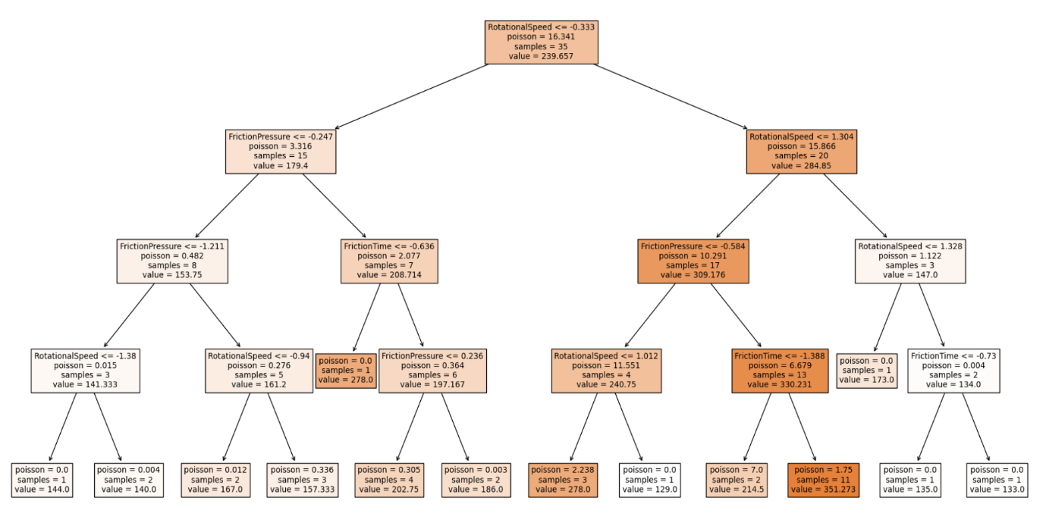

**Fig. 6. Architecture of Decision Tree**

Recursive partitioning creates decision tree architecture by splitting the node into its right and left child nodes, which in turn split into other child nodes. This process begins with the first parent, or the root node. Iteratively, the dataset is divided into features, beginning at the root node, based on the biggest Information Gain (IG). Divide the nodes with the most informative properties in order to maximize Information Gain (IG), as indicated by Equation 1.

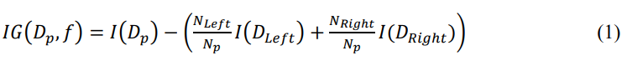

Where *Dp*, *DLeft*, *DRight* are the dataset of the child and parent nodes, are number of samples in child nodes, is the total number of samples at the parent node and is the impurity measure. The decision tree algorithm's performance as determined by measuring the Performance metrics is displayed in Table 4.

|  |  |  |
| --- | --- | --- |
| Mean absolute error | Mean squared log error | R2 Value |
| 28.189 | 0.019 | 0.865 |

**Table 4. Performance metrics evaluation of Decision Tree Algorithm**

4.2 Random Forest Algorithm

One supervised machine learning method that can be used for problems with regression and classification is the Random Forest algorithm. Decision trees make up this structure. The complex issue is resolved by combining multiple classifiers with ensemble learning. As can be seen in Figure 7, the expected output is created by taking the mean or average of the output that each decision tree produces. Table 6 presents the performance metrics evaluation of the Random Forest Algorithm.

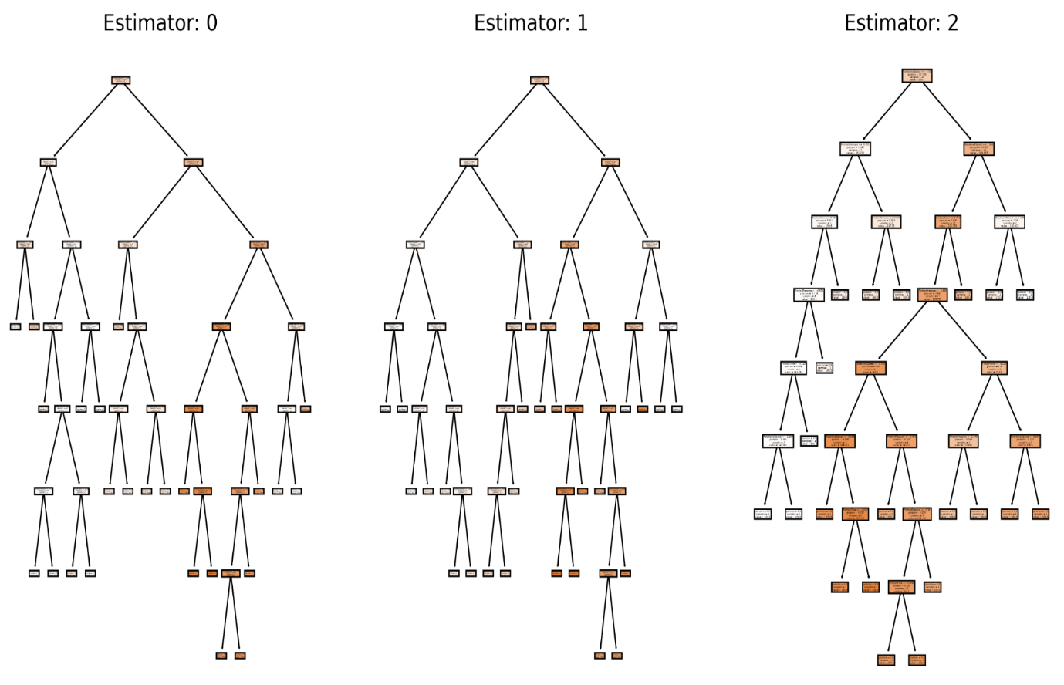

**Fig.7. Architecture of decision tress splitting in Random Forest Algorithm**

**Table 5. Performance metrics evaluation of Random Forest Algorithm**

|  |  |  |
| --- | --- | --- |
| Mean absolute error | Mean squared log error | R2 Value |
| 34.481 | 0.031 | 0.845 |

The MSE and MAE generated by the Random Forest Algorithm are higher than those of the Decision Tree Algorithm, despite the R2 value being only slightly lower.

4.3 Gradient Boosting Algorithm

In order to predict continuous values even more, the Gradient Boosting algorithm is an ensemble model that combines weak predictive models or several learners. Regression and classification are two uses for this method. It is employed as a regression algorithm in this work to forecast the tensile strength (MPa). An additive model is constructed by summing up several decision trees of a constant size that are weak predictive models. The decision tree-based estimators are fitted in order to forecast the samples' negative gradients in the dataset. There is an imperfect model Fm at each stage of m(1 ≤ m ≤ M) of gradient boosting, with M stages taken into consideration in the gradient boosting algorithm.

*Fm+1*(x) = *Fm* + *hm*(x) (2)

Below Table shows the performance evaluation of the Gradient Boosting Algorithm.

**Table 6. Performance metrics evaluation of Gradient Boosting Algorithm**

|  |  |  |
| --- | --- | --- |
| Mean absolute error | Mean squared log error | R2 Value |
| 23.551 | 0.022 | 0.890 |

In contrast to the other two algorithms, the Gradient Boosting Algorithm produces the greatest fit, with a value of 0.890. To summarize, the Gradient Boosting algorithm outperforms decision trees in terms of accuracy when predicting the output, or Tensile Strength (MPa).

1. CONCLUSION & FUTURE SCOPE OF WORK

In the current investigation, optimization of process parameters for joining similar γ TiAl alloys using Friction stir welding with the assistance of Machine learning has been carried out and the following conclusions can be drawn:

* Data set required for ML process is obtained from the literature and expanded using various mathematical algorithms
* Supervised machine learning regression-based algorithms, including Decision Trees, Gradient Boosting Algorithm, and Random Forest Algorithm, using Python programming were implemented
* The results highlighted that the highest tensile strength of 418 MPa and least tensile strength 127 MPa was achieved at specific parameter settings, indicating the importance of tool configuration and operating conditions. Interestingly, the tool material was found to have significant impact on the tensile strength in the dataset.

FUTURE SCOPE OF WORK:

* Looking ahead, the research suggests the future implementation of Quantum Machine Learning-based algorithms to further explore and compare their effectiveness with conventional Machine Learning Algorithms for advanced methodologies and continued improvement in optimizing FSW processes for enhanced mechanical properties in material processing.

REFERENCES

[1] N. S. Neelam, S. Banumathy, G. V. S. Nageswara Rao, and A. Bhattacharjee, “Study of microstructure and mechanical properties of γ-Ti-46.5Al-2Cr-(3.5 &amp; 5.0) Nb alloys,” *Mater Today Proc*, vol. 41, pp. 1069–1072, 2021, doi: 10.1016/j.matpr.2020.07.131.

[2] O. Genc and R. Unal, “Development of gamma titanium aluminide (γ-TiAl) alloys: A review,” *J Alloys Compd*, vol. 929, p. 167262, Dec. 2022, doi: 10.1016/j.jallcom.2022.167262.

[3] M. Amin Bozorgzadeh, “Friction Stir Welding,” 2015. [Online]. Available: www.ijrls.com

[4] R. S. Mishra and Z. Y. Ma, “Friction stir welding and processing,” *Materials Science and Engineering R: Reports*, vol. 50, no. 1–2. Aug. 31, 2005. doi: 10.1016/j.mser.2005.07.001.

[5] W. M. Thomas, “Friction Stir Welding - Recent Developments,” *Materials Science Forum*, vol. 426–432, pp. 229–236, Aug. 2003, doi: 10.4028/www.scientific.net/MSF.426-432.229.

[6] A. K. Singh, P. Sahlot, M. Paliwal, and A. Arora, “Heat transfer modeling of dissimilar FSW of Al 6061/AZ31 using experimentally measured thermo-physical properties,” *The International Journal of Advanced Manufacturing Technology*, vol. 105, no. 1–4, pp. 771–783, Nov. 2019, doi: 10.1007/s00170-019-04276-y.

[7] Andreas C, Müller, and Sarah Guido, *Introduction to Machine Learning with Python: A Guide for Data Scientists*. 2017. Accessed: Nov. 19, 2023. [Online]. Available: https://books.google.co.in/books?id=1-4lDQAAQBAJ&lpg=PP1&pg=PR2#v=onepage&q&f=false

[8] Z. Obermeyer and E. J. Emanuel, “Predicting the Future — Big Data, Machine Learning, and Clinical Medicine,” *New England Journal of Medicine*, vol. 375, no. 13, pp. 1216–1219, Sep. 2016, doi: 10.1056/NEJMp1606181.

[9] S. Park and S. Gupta, “Handling Endogenous Regressors by Joint Estimation Using Copulas,” *Marketing Science*, vol. 31, no. 4, pp. 567–586, Jul. 2012, doi: 10.1287/mksc.1120.0718.

[10] T. Xie and J. C. Grossman, “Crystal Graph Convolutional Neural Networks for an Accurate and Interpretable Prediction of Material Properties,” *Phys Rev Lett*, vol. 120, no. 14, p. 145301, Apr. 2018, doi: 10.1103/PhysRevLett.120.145301.

[11] T. DebRoy, T. Mukherjee, H. L. Wei, J. W. Elmer, and J. O. Milewski, “Metallurgy, mechanistic models and machine learning in metal printing,” *Nature Reviews Materials*, vol. 6, no. 1. Nature Research, pp. 48–68, Jan. 01, 2021. doi: 10.1038/s41578-020-00236-1.

[12] K. Gangwar and M. Ramulu, “Friction stir welding of titanium alloys: A review,” *Mater Des*, vol. 141, pp. 230–255, Mar. 2018, doi: 10.1016/j.matdes.2017.12.033.

[13] M. Ashraf Imam, “The 13th World Conference on Titanium (Ti-2015),” *JOM*, vol. 68, no. 9, pp. 2492–2501, Sep. 2016, doi: 10.1007/s11837-016-2045-4. [14] C. Liu, B. Wu, and J. X. Zhang, “Numerical Investigation of Residual Stress in Thick Titanium Alloy Plate Joined with Electron Beam Welding,” *Metallurgical and Materials Transactions B*, vol. 41, no. 5, pp. 1129–1138, Oct. 2010, doi: 10.1007/s11663-010-9408-y.

[15] D. Powers and G. Schubert, “Electron beam welding: A useful tool for the automotive industry,” vol.

[16] P. Wanjara, M. Brochu, and M. Jahazi, “Thin Gauge Titanium Manufacturing Using Multiple-Pass Electron Beam Welding,” *Materials and Manufacturing Processes*, vol. 21, no. 5, pp. 439–451, Aug. 2006, doi: 10.1080/10426910500471425.

[17] R. NANDAN, T. DEBROY, and H. BHADESHIA, “Recent advances in friction-stir welding – Process, weldment structure and properties,” *Prog Mater Sci*, vol. 53, no. 6, pp. 980–1023, Aug. 2008, doi: 10.1016/j.pmatsci.2008.05.001.

[18] N. Mendes, P. Neto, A. Loureiro, and A. P. Moreira, “Machines and control systems for friction stir welding: A review,” *Mater Des*, vol. 90, pp. 256–265, Jan. 2016, doi: 10.1016/j.matdes.2015.10.124.

[19] Sónia Simões, Filomena Viana, and Manuel F. Vieira, *Joining Technology of γ-TiAl Alloys*.

[20] A. Mishra, P. Di Milano, A. A. Bahir, E. Messele Sefene, and A. A. Tsegaw, “Process parameter optimization of 6061AA Friction Stir Welded Joints using Supervised Machine Learning Regression-based Algorithms Process parameter optimization of Friction Stir Welding on 6061AA using Supervised Machine Learning Regression-based Algorithms”, doi: 10.33774/chemrxiv-2021-hh7nn.